Test Case: tc002_SPX_Dev5_Crear_Requisicion_Spot_Con_FAD_Tipo_Cobro_CC
Step 1 - Enter username and password and click to button Enter : Credentials Entered
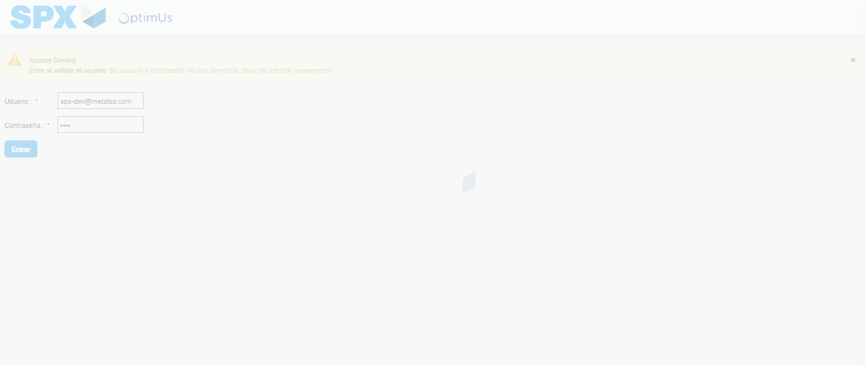Image file-name: QC_Testing-tc002_SPX_Dev5_Crear_Requisicion_Spot_Con_FAD_Tipo_Cobro_CC-1790178816732

Step 2 - Select to UEN and Access to Spot Buy Requisitions : UEN Correctly selected and Correct access
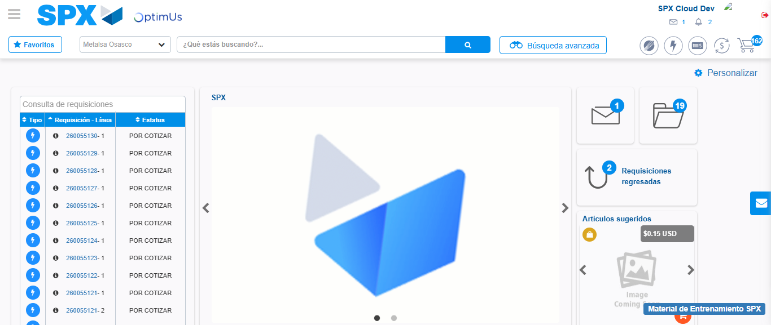Image file-name: QC_Testing-tc002_SPX_Dev5_Crear_Requisicion_Spot_Con_FAD_Tipo_Cobro_CC-1790178847347

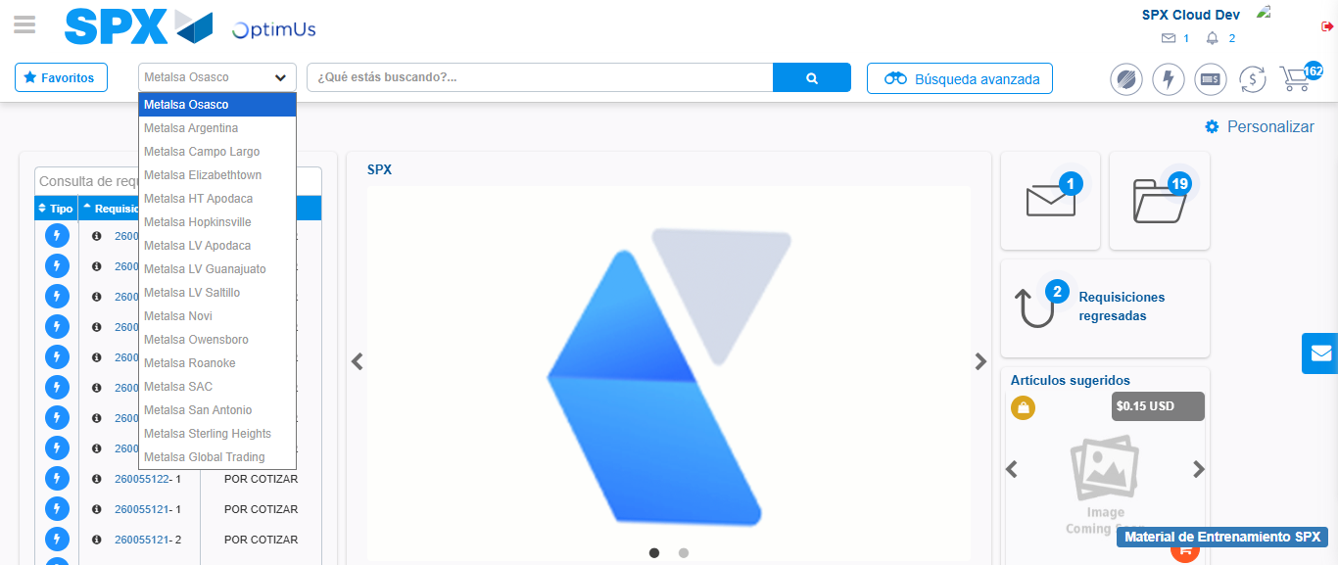Image file-name: QC_Testing-tc002_SPX_Dev5_Crear_Requisicion_Spot_Con_FAD_Tipo_Cobro_CC-1790178847829

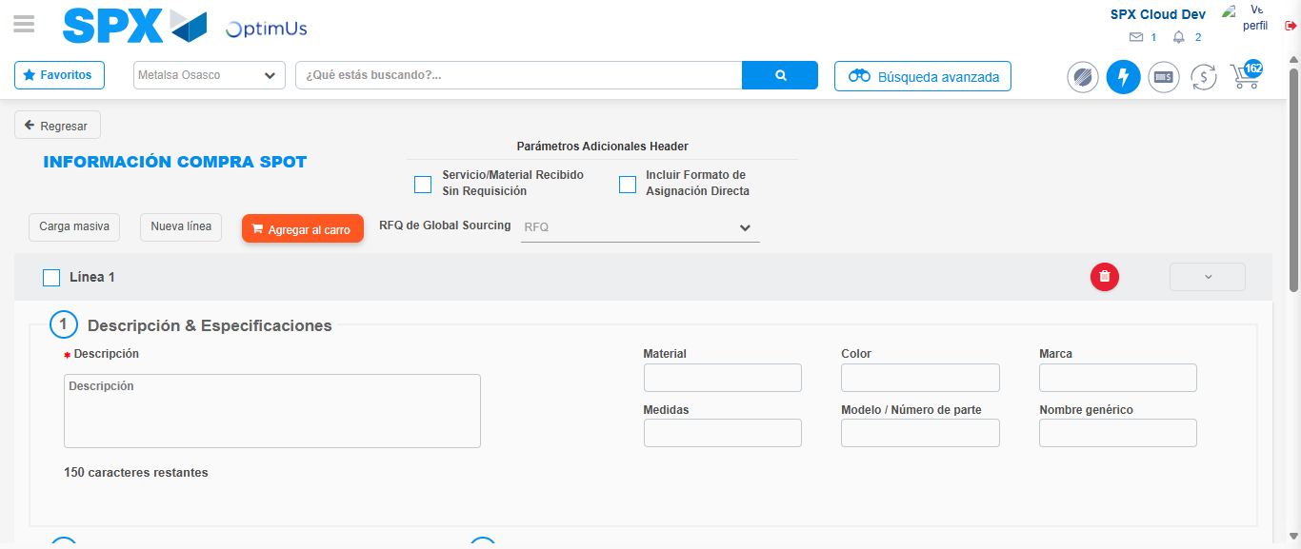Image file-name: QC_Testing-tc002_SPX_Dev5_Crear_Requisicion_Spot_Con_FAD_Tipo_Cobro_CC-1790178855222

Step 3 - Add FAD to Requisition: FAD Successfully Added
Image file-name: QC_Testing-tc002_SPX_Dev5_Crear_Requisicion_Spot_Con_FAD_Tipo_Cobro_CC-1790178855430

Image file-name: QC_Testing-tc002_SPX_Dev5_Crear_Requisicion_Spot_Con_FAD_Tipo_Cobro_CC-1790178855595

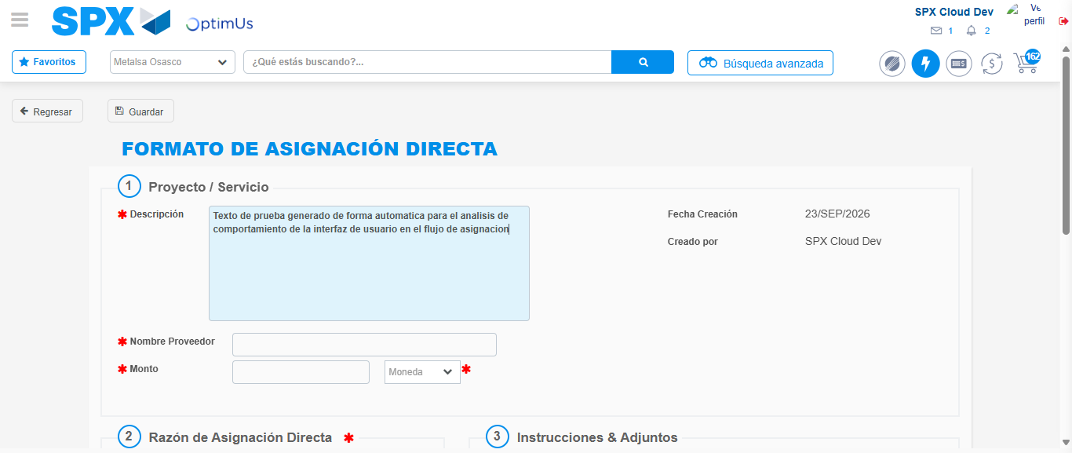Image file-name: QC_Testing-tc002_SPX_Dev5_Crear_Requisicion_Spot_Con_FAD_Tipo_Cobro_CC-1790178858279

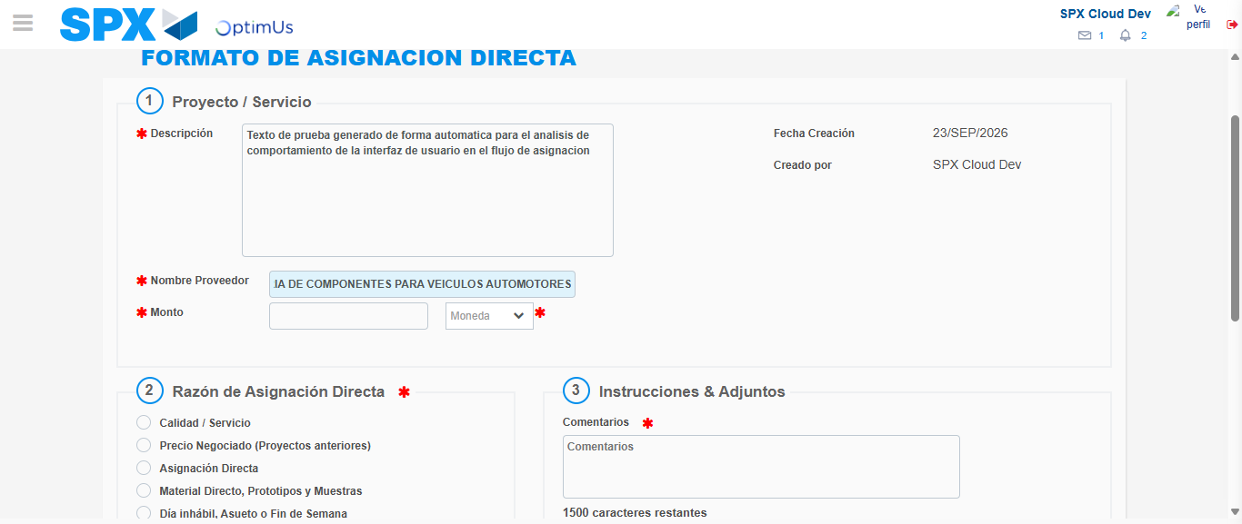Image file-name: QC_Testing-tc002_SPX_Dev5_Crear_Requisicion_Spot_Con_FAD_Tipo_Cobro_CC-1790178866559

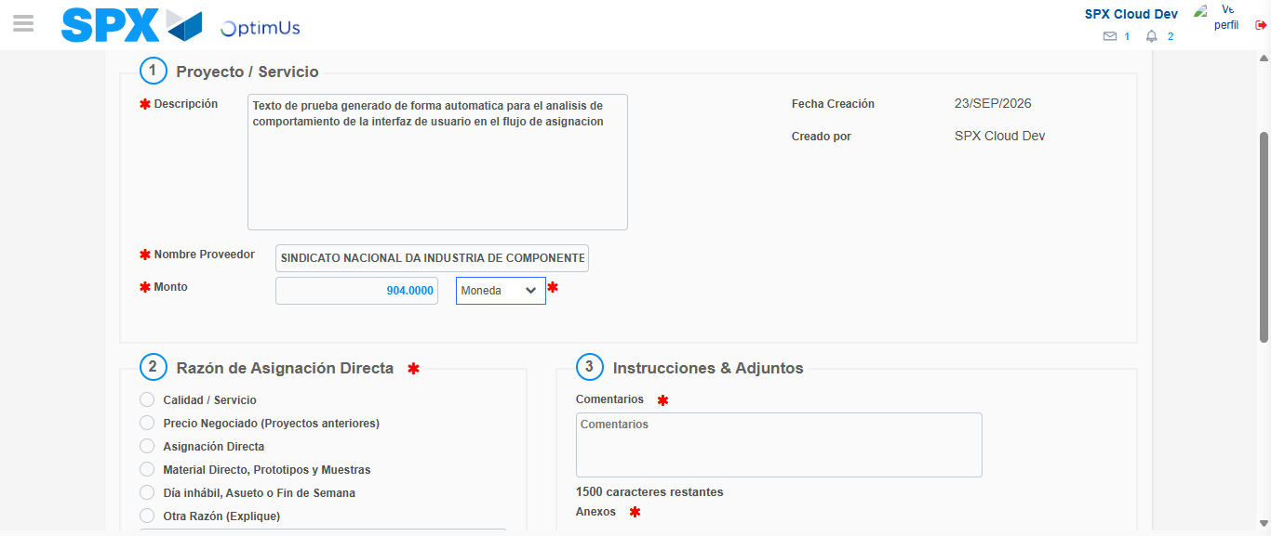Image file-name: QC_Testing-tc002_SPX_Dev5_Crear_Requisicion_Spot_Con_FAD_Tipo_Cobro_CC-1790178866878

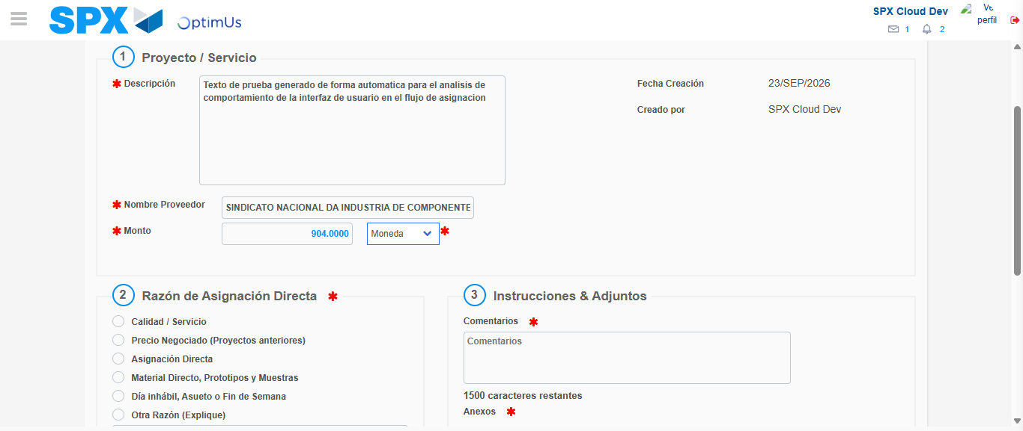Image file-name: QC_Testing-tc002_SPX_Dev5_Crear_Requisicion_Spot_Con_FAD_Tipo_Cobro_CC-1790178867078

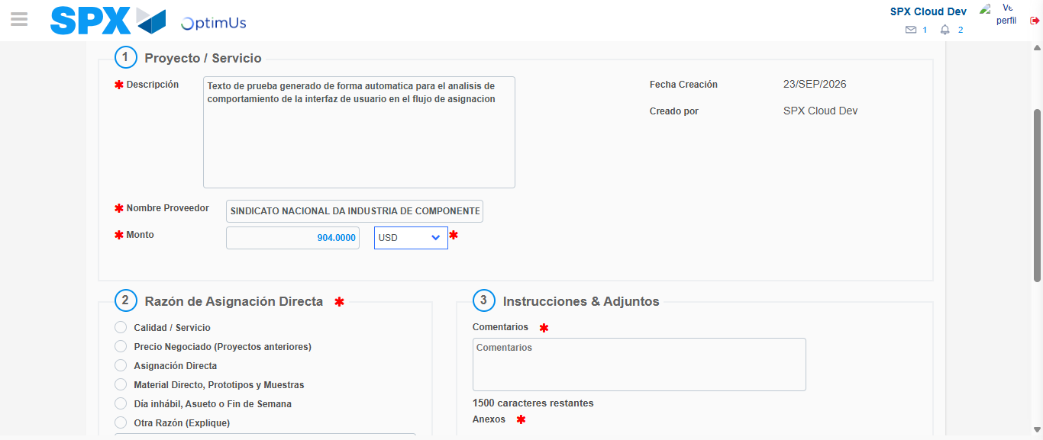Image file-name: QC_Testing-tc002_SPX_Dev5_Crear_Requisicion_Spot_Con_FAD_Tipo_Cobro_CC-1790178867376

Image file-name: QC_Testing-tc002_SPX_Dev5_Crear_Requisicion_Spot_Con_FAD_Tipo_Cobro_CC-1790178867549

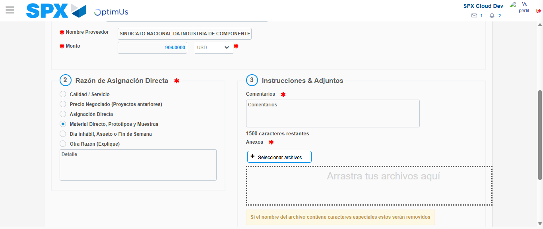Image file-name: QC_Testing-tc002_SPX_Dev5_Crear_Requisicion_Spot_Con_FAD_Tipo_Cobro_CC-1790178868316

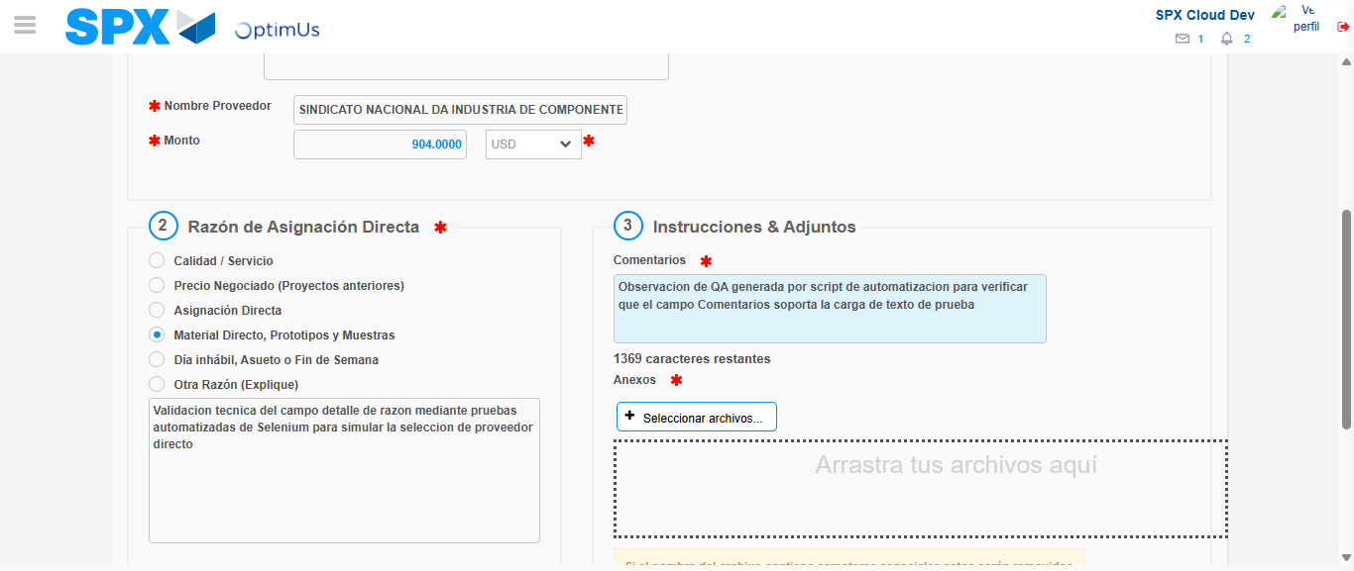Image file-name: QC_Testing-tc002_SPX_Dev5_Crear_Requisicion_Spot_Con_FAD_Tipo_Cobro_CC-1790178879266

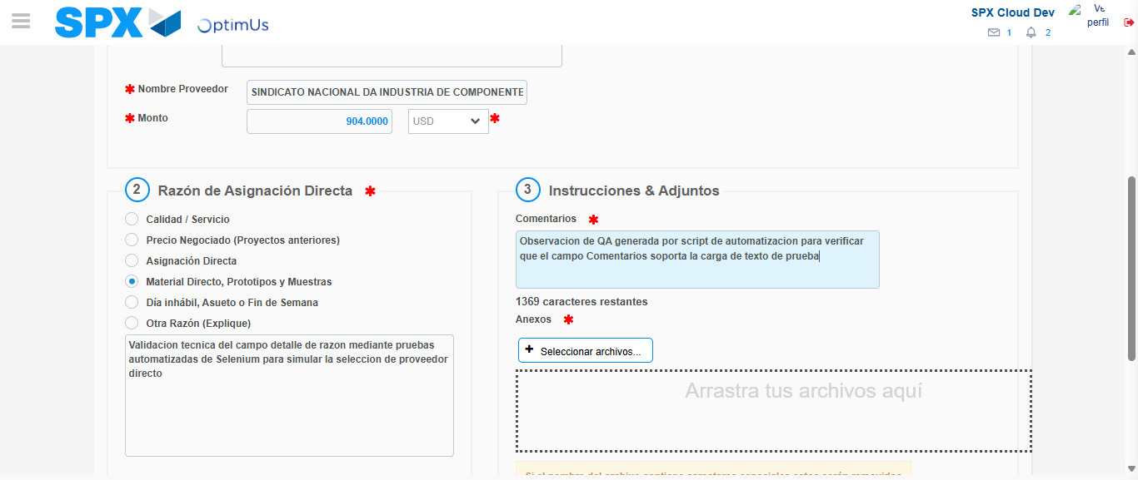Image file-name: QC_Testing-tc002_SPX_Dev5_Crear_Requisicion_Spot_Con_FAD_Tipo_Cobro_CC-1790178879819

Step 4 - Data Capture Spot Buy Requisition: Data captured correctly
Image file-name: QC_Testing-tc002_SPX_Dev5_Crear_Requisicion_Spot_Con_FAD_Tipo_Cobro_CC-1790178855430

Image file-name: QC_Testing-tc002_SPX_Dev5_Crear_Requisicion_Spot_Con_FAD_Tipo_Cobro_CC-1790178855595

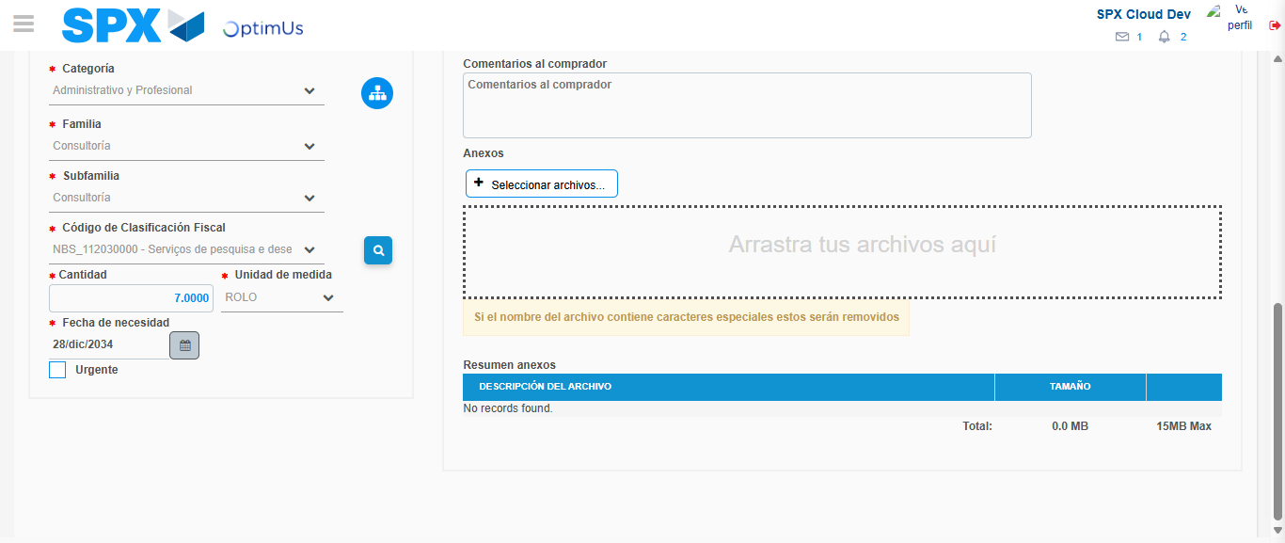Image file-name: QC_Testing-tc002_SPX_Dev5_Crear_Requisicion_Spot_Con_FAD_Tipo_Cobro_CC-1790178898190

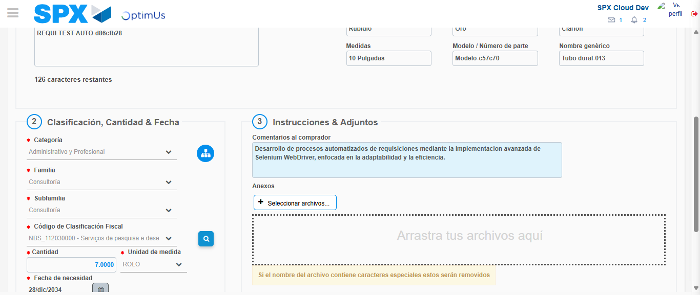Image file-name: QC_Testing-tc002_SPX_Dev5_Crear_Requisicion_Spot_Con_FAD_Tipo_Cobro_CC-1790178908936

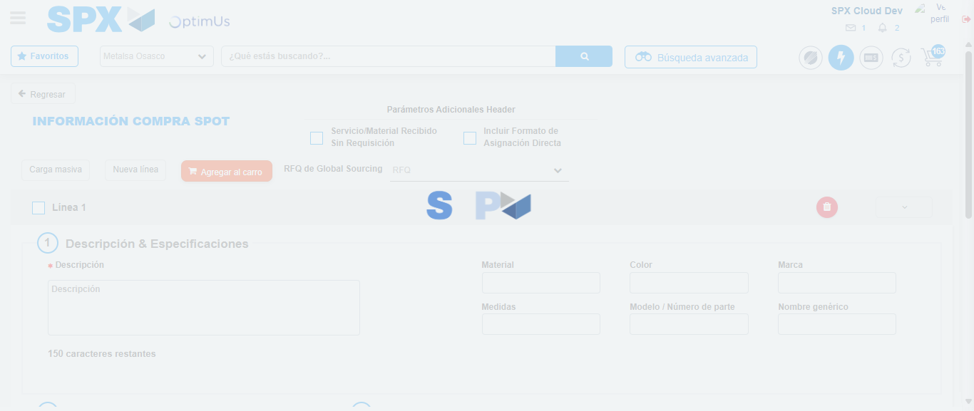Image file-name: QC_Testing-tc002_SPX_Dev5_Crear_Requisicion_Spot_Con_FAD_Tipo_Cobro_CC-1790178922237

Step 8 - Return to Main Page SPX : Return to Main Page SPX
Image file-name: QC_Testing-tc002_SPX_Dev5_Crear_Requisicion_Spot_Con_FAD_Tipo_Cobro_CC-1790178847347

Image file-name: QC_Testing-tc002_SPX_Dev5_Crear_Requisicion_Spot_Con_FAD_Tipo_Cobro_CC-1790178847829

Image file-name: QC_Testing-tc002_SPX_Dev5_Crear_Requisicion_Spot_Con_FAD_Tipo_Cobro_CC-1790178855222

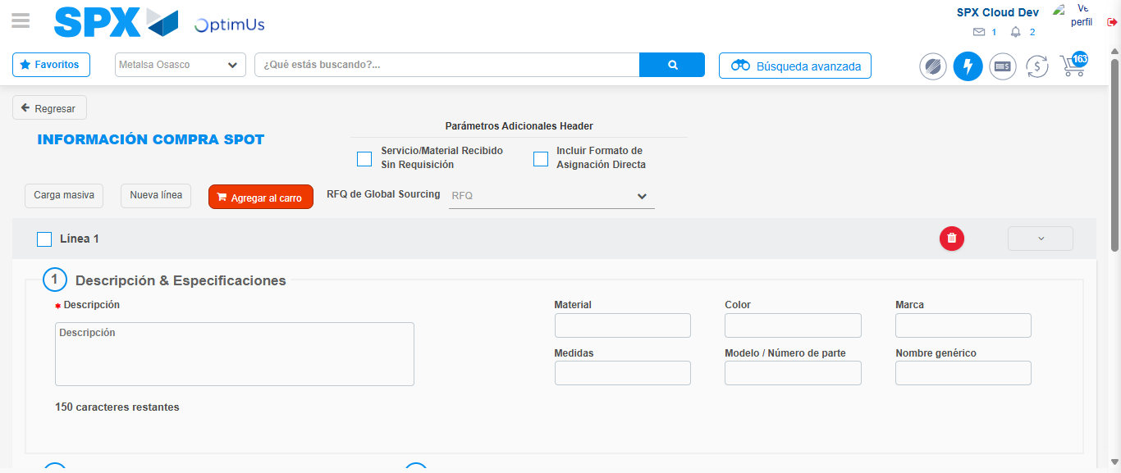Image file-name: QC_Testing-tc002_SPX_Dev5_Crear_Requisicion_Spot_Con_FAD_Tipo_Cobro_CC-1790178924444

Image file-name: QC_Testing-tc002_SPX_Dev5_Crear_Requisicion_Spot_Con_FAD_Tipo_Cobro_CC-1790178924608

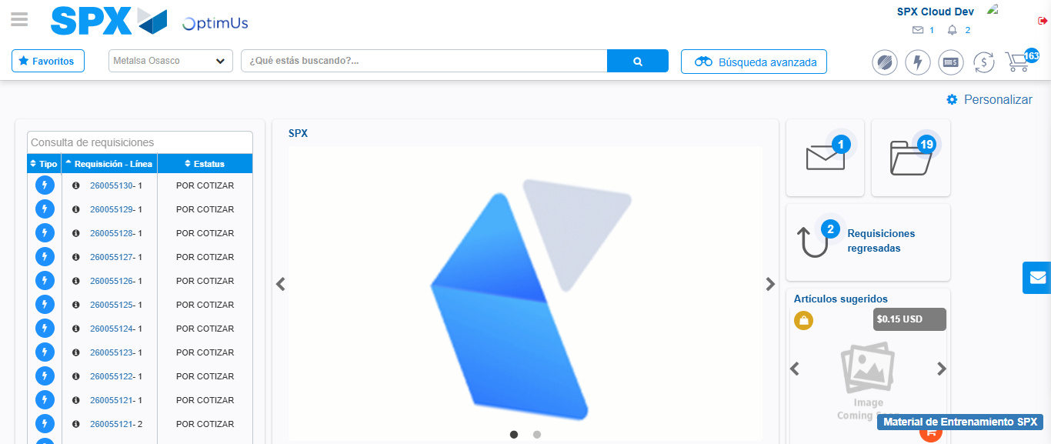Image file-name: QC_Testing-tc002_SPX_Dev5_Crear_Requisicion_Spot_Con_FAD_Tipo_Cobro_CC-1790178945679

Step 9 - Log Out : Log Out SPX
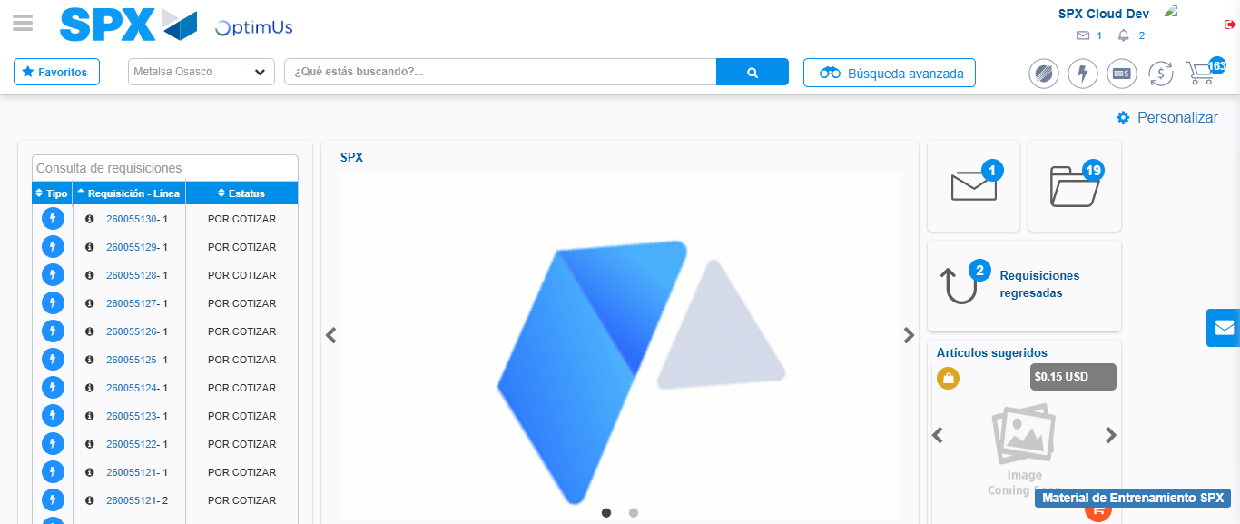Image file-name: QC_Testing-tc002_SPX_Dev5_Crear_Requisicion_Spot_Con_FAD_Tipo_Cobro_CC-1790178945934

